**BSc (Hons) in Information Technology**

**Software Engineering – Year 3 Semester 2, 2022**

**SE3050 – User Experience engineering**

**Milestone 02**

**Team BIKO - SER_027**

IT20004118

Bandara G.K.A.H

**Table of Contents**

Table of Contents

**Goal**3

**Research questions** 3

**Method**

**1. Interviews**4-5

**2. Video Recordings**6

**3. Questionnaires**6-11

**Participant Profiles**11

**Prototype** 11-12

Goal

According to my persona, looking for a solution that will bring more easy and time saving methods to manage the workload is my main goal. To achieve this goal, I want to plan a user research to clearly understand the experience that the user is getting usually. I am going to clarify the current problems regarding handling data and assigning the work among the drivers through this user research for my persona.

Research Questions

How they keep records about tea sellers and lorry drivers

How to arrange route timetables

How to give awareness to the seller about the route details

How to give awareness to the lorry details about the route details

Method

Interviewing

|  |
| --- |
| * Hi ,how are you doing today? * Thank you for lending your valuable time for us today! * We will start with some questions, so please share your honest thoughts as we go along. There are no right or wrong answers. * Do you have any questions for me before we get started? * Before we begin could I just confirm that you are still okay with this session being recorded and shared * with our module in charge? [wait for reply] * Ok. I will start the recording now.[PRESS RECORD]   (හායි, අද ඔබට කොහොමද?  ඔබගේ වටිනා කාලය අද අප වෙනුවෙන් කැප කිරීම ගැන ඔබට ස්තුතියි!  අපි ප්‍රශ්න කිහිපයකින් ආරම්භ කරන්නෙමු,  කරුණාකර ඔබේ අවංක අදහස් අප සමග බෙදා ගන්න  ආරම්භ කිරීමට පෙර ඔබට මගෙන් ප්‍රශ්න ඇසිමට තිබේ ද  මෙම සැසිය පට්ගත කීරීම සම්බන්ධයන් ඔබට ගැටලුවක් තිබේ ද?  එසේනම් අපි සැසිය ආරම්භ කරමු.)   * How long have you been working for this factory? (ඔබ කොපමණ කාලයක් මෙම කර්මාන්ත ශාලාවේ සේවය කරනවාද?) * Do you have experience in handling automated systems or applications? (ස්වයංක්‍රීය පද්ධති හෝ යෙදුම් හැසිරවීමේ පළපුරුද්ද ඔබට තිබේද?)   + If yes, how many years of experience do you have? (ඔව් නම්, ඔබට වසර කීයක් පළපුරුද්ද තිබේද?)   + What kind of systems or applications have you used? (ඔබ භාවිතා කර ඇත්තේ කුමන ආකාරයේ පද්ධති හෝ යෙදුම්ද?)   + If not, will an IT related course help you to gain enough knowledge on handling an automated system? (එසේ නොමැති නම්, ස්වයංක්‍රීය පද්ධතියක් හැසිරවීම පිළිබඳ ප්‍රමාණවත් දැනුමක් ලබා ගැනීමට තොරතුරු තාක්ෂණ සම්බන්ධ පාඨමාලාවක් ඔබට උපකාර කරයිද?)     - If not, will another person with much better IT knowledge will do the controlling be accepted? (එසේ නොවේ නම්, වඩා හොඳ තොරතුරු තාක්ෂණ දැනුමක් ඇති වෙනත් අයෙකු පාලනය කරයිද පිළිගත හැකිද?) * Do you use papers to keep records on the details? (විස්තර මත වාර්තා තබා ගැනීමට ඔබ කඩදාසි භාවිතා කරනවාද?)   + If yes, is it easy or difficult to work with so many papers? (විස්තර මත වාර්තා තබා ගැනීමට ඔබ කඩදාසි භාවිතා කරනවාද?)     - What are the difficulties you face? (ඔබ මුහුණ දෙන දුෂ්කරතා මොනවාද?)   + If no, what is the method you use? (එසේ නොවේ නම්, ඔබ භාවිතා කරන ක්‍රමය කුමක්ද?)     - If used another automated system or an application what is that application? (වෙනත් ස්වයංක්‍රීය පද්ධතියක් හෝ යෙදුමක් නම් එම යෙදුම කුමක්ද?)     - What are the good and bad experiences when using that app? (එම යෙදුම භාවිතා කරන විට ඇති හොඳ සහ නරක අත්දැකීම් මොනවාද?) |

* Video recording

Reference to the file name – Interview video

* Questionnaire

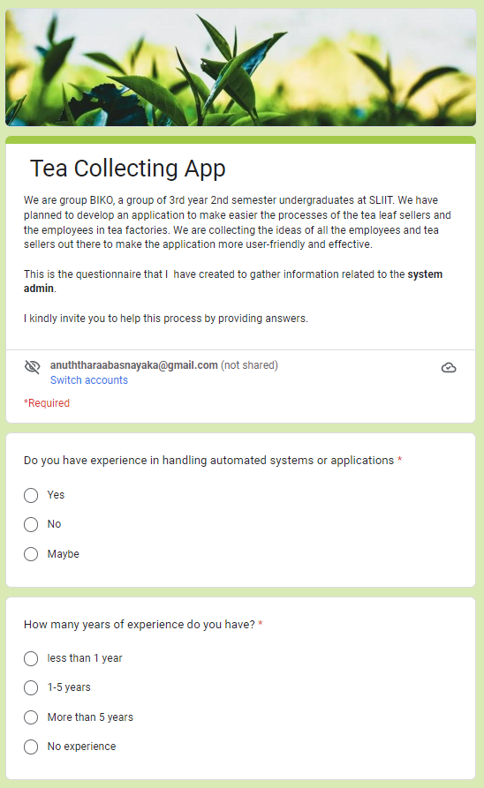

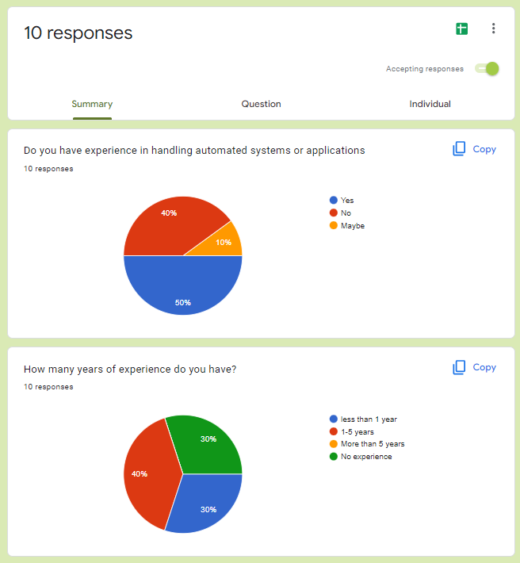

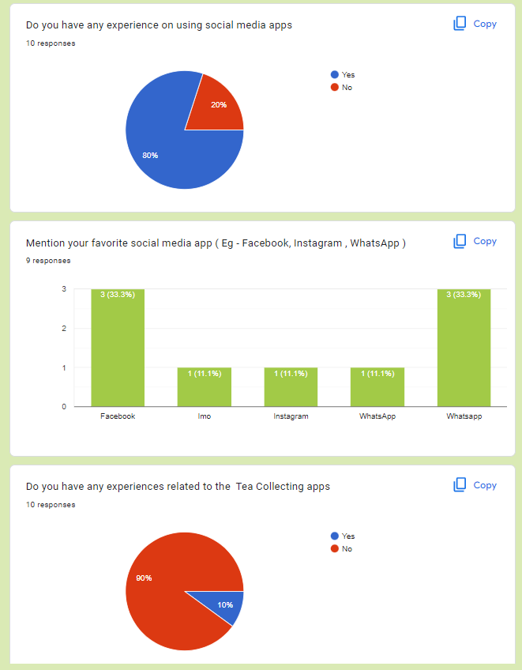

Participants

|  |  |  |
| --- | --- | --- |
| Name | Demography | Location, Date and Time |
| G K N Ruchiranga | **Age:** 25  **Gender:** Male  **Marital Status:** Single  **Location:** Rathnapura, Sri Lanka  **Profession:** Tea Factory Manager | **Location:** Rathnapura, Sri Lanka  **Date:** 26/09/2022  **Time:** 11.30 am |

Protocol

The user research was planned to conduct as a user interview session. I have found the real user who match to my persona and decided to meet that person via online platform. I have selected a Tea Factory Manager who lives in a Rathnapura, which is located in Sabaragamuwa province. The date we planned to do the interview was 24th September 2022 at 8.30 am via online.

When conducting the interview, due to the request of the person I had to conduct the meeting via online. As my persona is related to a System admin, I have met G K N Ruchiranga who is a Tea Factory Manager via online platform.

I planned to check the documents to get a more clear idea regarding the data categories that are need to be more focused in lorry routes details and seller details. I have a goal to use those details to make the application to access frequently used data easily and to create more accurate map details for timetables.